ROTATEQ CALCULATOR



<https://profesionales.msd.es/medicos/lp/rotateq-18/calculadora.xhtml>

-Next I Will explain how this development is divided and mostly how the .JS it´s been done.

I´ve created 3 files with the html, css and js codes:

* JS-CALCULADORA-ROTATEQ.js
* CSS-CALCULADORA-ROTATEQ.css
* HTML-CALCULADORA-ROTATEQ.html

**\*About the .JS it´s important to consider that it uses the modernizer library**

<!--Adding Modernizr -->

<script src="https://cdnjs.cloudflare.com/ajax/libs/modernizr/2.8.3/modernizr.js"></script>

The behavior of the calculator starts here:



You chose which dose you want to calculate and after that you need to complete the necessary dates for the calculation

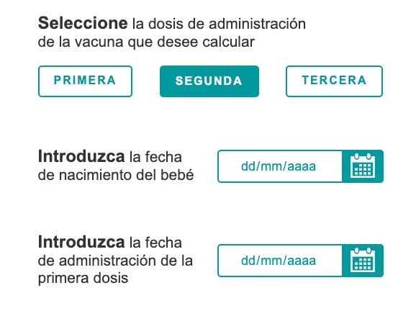

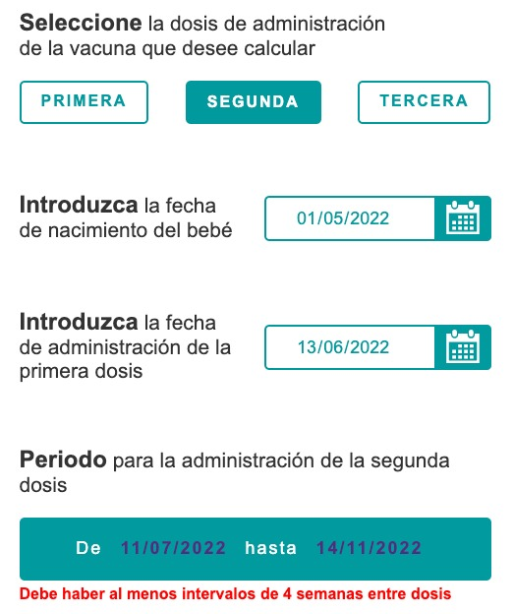

About the code we are going to explain some of the main functions

**function appear1()**

**function appear2()**

**function appear3()**

Those functions just display the datepickers and messages for programmed for each dose

And as well we have these functions

**function primeraDosis()**

**function segundaDosis()**

**function terceraDosis()**

those functions calculates the period ou have to take that dose